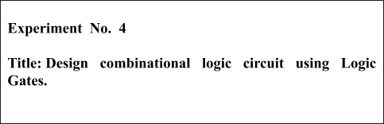

**Batch: B1 Roll No.: 1914078 Experiment No.: 4**

**Aim:** Design combinational logic circuit using Logic Gates.​

**_______________________________________________________________ ___ _** **Resources needed:** Simulation Platform​

**Theory:**

What is the Combinational Logic Circuit?

**Ans:**

In combinational circuits, the outputs at any instant of time depend upon the inputs present at that instant of time. This means there is no memory in these circuits. There are other types of circuits in which the outputs at any instant of time depend upon the present inputs as well as past inputs/outputs. There are two different approaches to the design of combinational circuits.One of these is traditional method,where the given boolean expression or truth table is simplified using standard methods and the simplified expression is realised using gates.The other method uses complex logic functions available in MSI (Medium scale integrated circuit)

**Problem Statement**

Figure shows the intersection of a main highway with a secondary access road. Vehicle-detection sensors are placed along lanes *C*​​and *D*​​(main road) and lanes *A*​​and *B*​(access road). These sensor outputs are LOW (0) when no vehicle is present and HIGH (1) when a vehicle is present. The intersection traffic light is to be controlled according to the following logic:

1. The east-west (E-W) traffic light will be green whenever *both* ​ ​lanes *C* ​ ​and *D* ​ ​are occupied. 2. The E-W light will be green whenever *either*​ *C* ​or *D*​​is occupied but lanes *A*​​and *B*​​are not *both* ​occupied.

1. The north-south (N-S) light will be green whenever *both*​ ​lanes ​*A* ​and *B*​​are occupied but *C*​and *D* ​ ​are not *both* ​ ​occupied.
2. The N-S light will also be green when *either*​ *A* ​or *B*​​is occupied while *C*​​and *D*​​are *both*​vacant.
3. The E-W light will be green when *no* ​ ​vehicles are present.

Using the sensor outputs *A*​ ​, *B*​ ​, *C,*​​and *D*​​as inputs, design a logic circuit to control the traffic light. There should be two outputs, N-S and E-W, that go HIGH when the corresponding light is to be *green.* ​ ​Simplify the circuit as much as possible and show *all* ​ ​steps.

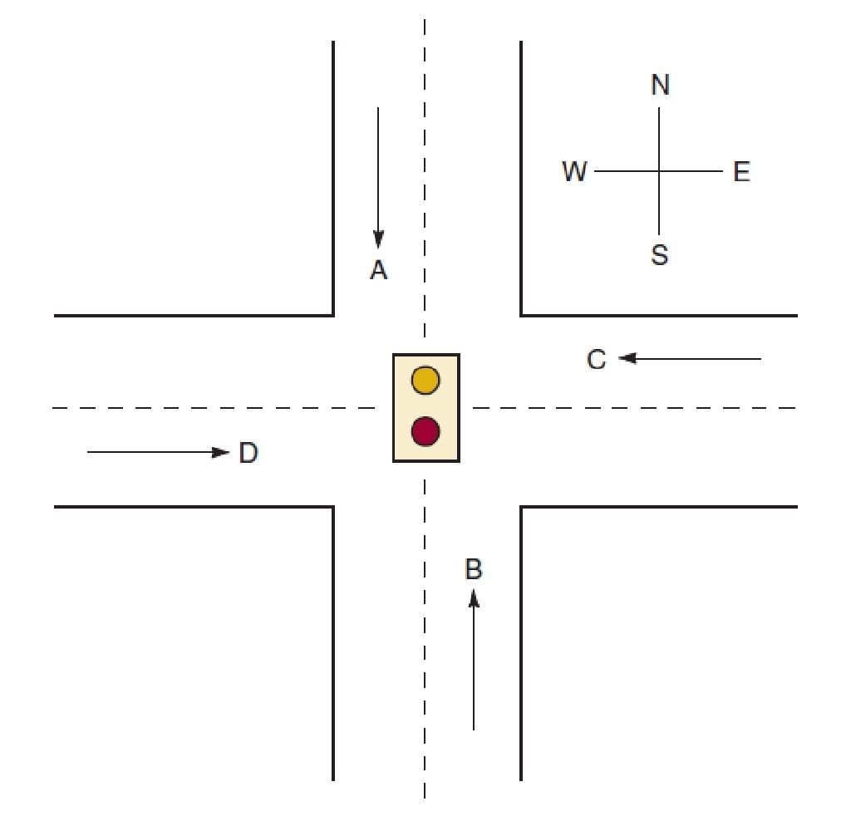

**Procedure**:​

a) Design combinational circuits as per given problem definition.

b)Simulate.

c) Verify the designed truth table.

d)Upload the Schematic Diagram generated on Simulation Software as well as Writeup containing Questions asked in writeup, CO and Conclusion.

e) Please note every document uploaded on google classroom should be labelled as Exp_<No>_<RollNo>_<schematic/writeup>.pdf

**___________________________________________________________________________**

**Observations and Results:**

**Equations:**

Using truth table and K-Map method we obtain the following equation for N-S

N-S= C’D’(A+B) + AB(C’+D’)

The output of E-W is just the opposite of the output of N-S.

E-W=(N-S)’

**Circuit:**

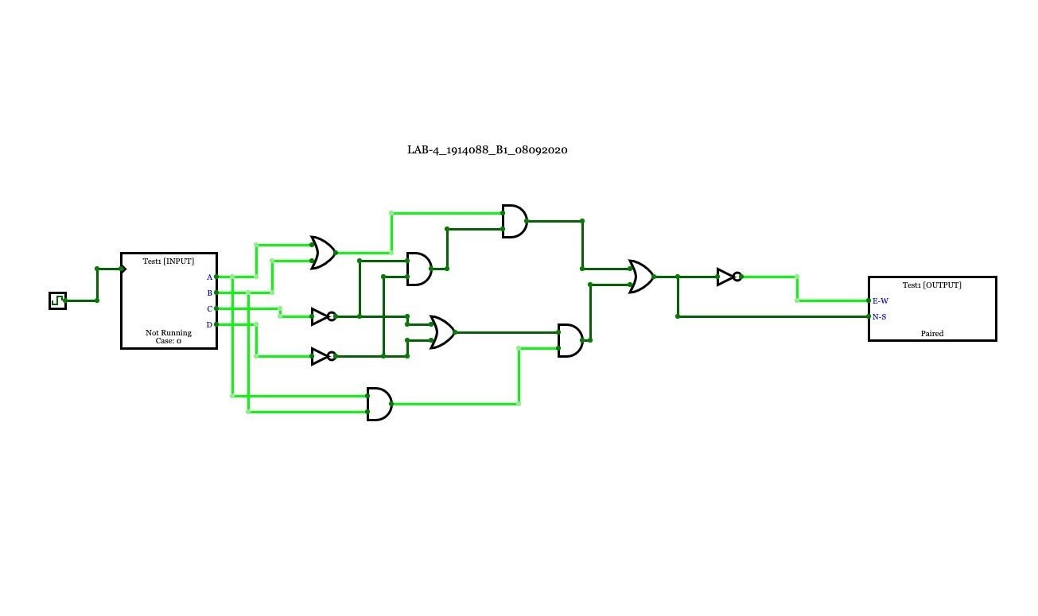

**JSON data of Test Bench:**

{"n":16,"inputs":[{"bitWidth":"1","label":"A","values":["0","0","0","0","0","0","0","0","1","

1","1","1","1","1","1","1"]},{"bitWidth":"1","label":"B","values":["0","0","0","0","1","1","1"

,"1","0","0","0","0","1","1","1","1"]},{"bitWidth":"1","label":"C","values":["0","0","1","1","

0","0","1","1","0","0","1","1","0","0","1","1"]},{"bitWidth":"1","label":"D","values":["0","1" ,"0","1","0","1","0","1","0","1","0","1","0","1","0","1"]}],"outputs":[{"bitWidth":"1","label":

"E-W","values":["1","1","1","1","0","1","1","1","0","1","1","1","0","0","0","1"]},{"bitWidth

":"1","label":"N-S","values":["0","0","0","0","1","0","0","0","1","0","0","0","1","1","1","0"]} ]}

**___________________________________________________________________________ Outcomes:** Understand the basic building blocks, techniques, used in digital logic design and design the combinational circuit using these basic building blocks.

**__________________________________________________________________________**

**Conclusion:**  We illustrated the use of Combinational Logic Circuits to solve the given problem statement.

**__________________________________________________________________________**

**Grade: AA / AB / BB / BC / CC / CD /DD**

**Signature of faculty in-charge with date**

**___________________________________________________________________________**